EXPERIMENT 3

Database Schema for a customer-sale scenario
Customer(Cust id : integer, cust_name: string)
Item(item_id: integer, item_name: string, price: integer)
Sale(bill_no:integer,bill_data:date,cust_id: integer, item_id: integer, qty_sold: integer)

1.Create the tables with the appropriate integrity constraints.
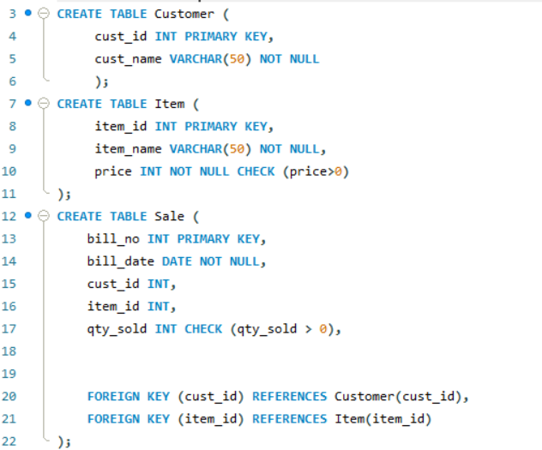

2. Insert around 10 records in each of the tables.

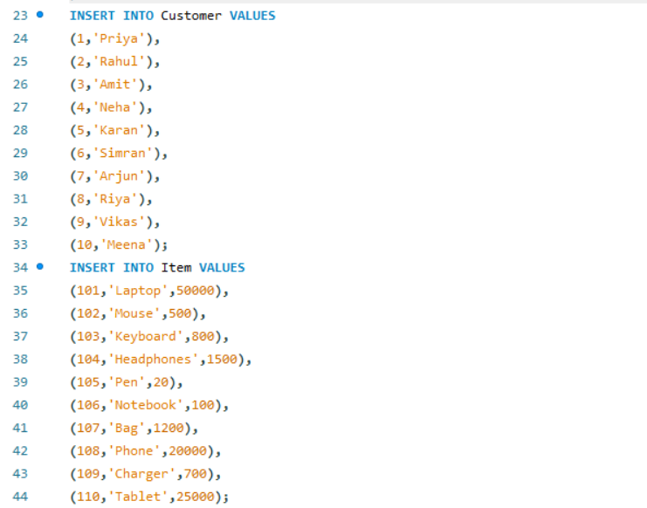
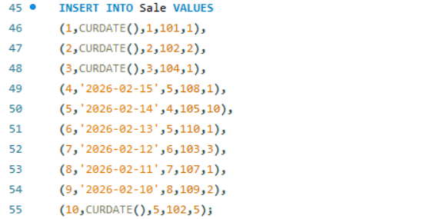

3. List all the bills for the current date with the customer names and item numbers.

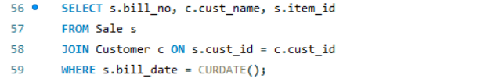

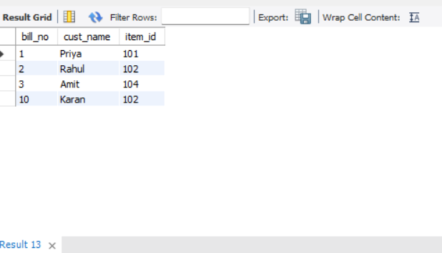

4. List the total Bill details with the quantity sold, price of the item and the final amount.
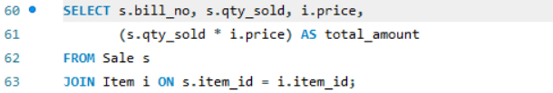
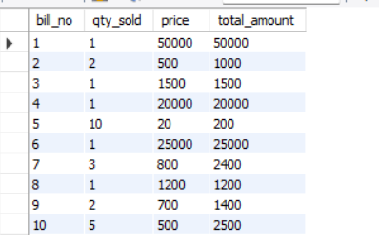

5.List the details of the customer who have bought a product which has a price>200.
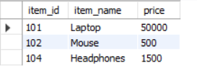
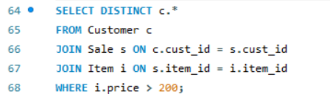

6.Give a count of how many products have been bought by each customer.

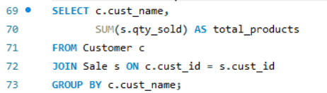
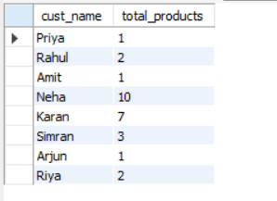
7.Give a list of products bought by a customer having cust_id as 5.

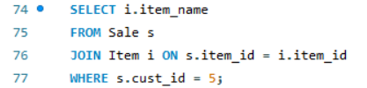
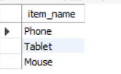

8.List the item details which are sold as of today.

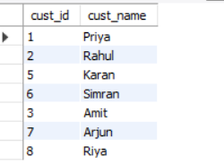
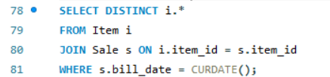

9. Create a view which lists out the bill_no, bill_date, cust_id, item_id, price, qty_sold, amount.
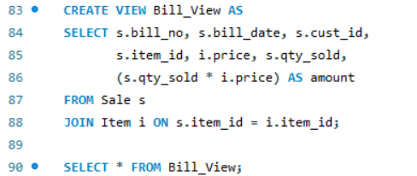
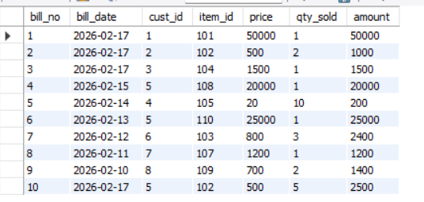

10. Create a view which lists the daily sales date wise for the last one week.
